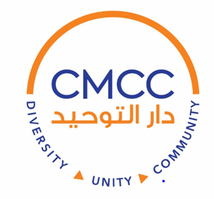

Space Rental Agreement, Policies and Procedures

APPLICANT INFORMATION:

**Name of Organization:**

Your Name:

Organization Title:

Address:

Email:

Tel:

**Event Information**:

Activity:

Event Date: Day of Week:

Event Start Time (include set-up): Event End Time (include clean-up):

What is the maximum number of people you expect to attend?

Will you need additional Equipment? □ Yes □ No What kind?

**HALL RATES:** $200 for 4 Hours

If using the facility outside the Sport Court the charges may vary, depending space usage.

**AMOUNT PAID AT RESERVATION**: The host of the event agrees to pay Colorado Muslim Community Center (CMCC) 50% as a deposit and reservation confirmation.

This amount is non-refundable, if cancelled within 30 days of the event. There will be a full refund if the cancellation is done 30 days prior to the event.

The remaining 50% will be paid 3 days before the day of the event prior to the commencement of preparation of the hall. The amount of $50 will be deposited and will be returned after the event.

Acceptable payment is Cash, Credit Card, Money Order or Cashier Checks.

The host/hostess agrees to the terms and conditions set forth in this package and acknowledges having read the same.

The host/hostess agrees that this agreement is binding upon the person who signs the contract. It does not cover any other entity and this agreement is nontransferable. The hall may not be sublet under any circumstances.

The host/hostess assumes full responsibility for the character, act and conduct of all persons admitted into the premises. CMCC shall not be held responsible for any damage and or injury to any persons including death or for any loss of or damage to the property of the attendees of the event. The host/hostess agrees to indemnify CMCC and hold harmless its agents, servants, employees, volunteers and executive officers from any such occurrences.

Any damage(s) that occurs to the facility that are a direct result of the renter or his/her guests will be the responsibility of the signer of this agreement. CMCC will charge the signer of this agreement the cost of the repairs to fix the damage.

CMCC is a non-smoking facility and this policy will be strictly enforced. Anyone found in violation of this policy will be asked to leave the premises.

Under no circumstances is any type of alcoholic beverages or illegal drugs Allowed on the premises. A violation of this policy will result in immediate cancellation of the event. The host/hostess acknowledges that in such circumstances, there shall be no refund of any kind and that CMCC Has the obligation to report such behavior to responsible authorities.

Music of any kind is not permissible in the premises; free mixing of the genders is not allowed on the premises.

The host/hostess acknowledges that he/she shall ensure the event is conducted according to Islamic principles, including respecting the prayers and adthan timings.

The host/hostess acknowledges that this form has to be completed, signed and submitted along with a deposit in order to reserve the hall.



*By signing this agreement, the signer agrees that he/she has read this agreement completely and has understood it in its entirety and agrees to comply with the conditions set forth in this agreement.*